Chapter 5 energy

5.1 Basics of energy

Forms of energy
Sound energy
- Given out when object vibrates
Chemical energy
- In fuels, Batteries and food
- Released as other forms of energy
Light energy
Thermal energy
- Higher temperature = higher thermal energy
Kinetic energy
- Moving -> kinetic energy
Potential energy
- Higher-> more potential energy
Electrical energy
- Be obtained from batteries
- Supplied from power cables
- In nature

Units of energy
Joules(J)
- Energy unit
Kilojoules(kj)
- 1000 joules
Calorie(cal)
- Energy value of food
Kilocalories(kcal)
- 1000 calorie

5.2 Energy conversion

Energy conversion
- E.g. idk

Energy conservation
Law of conservation of energy
- Energy can be converted
- But cannot be created or destroyed
Sankey diagram
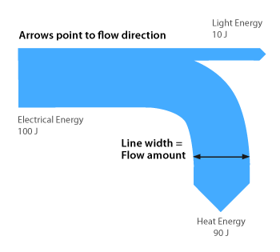
- No need to shade

Efficiency of energy conservation
Energy converters
- Electric fan
Efficiency
$$Efficiency=\frac{Useful energy output}{Total energy input}×100\%$$

5.3 Heat transfer
- Energy is transferred from the hot drink to your hands

Conduction
- Process of heat transfer
- Requires a medium such as solid, liquid or gas to transfer heat
- Can take place in an object or two objects that are in contact
- From hot end to cold end
- Metals -> good conductor of heat
- Non-metals -> poor conductor of heat(insulators of heat)
- Water and air are poor conductor of heat
Applications of good conductor: cooking utensils, heat sinks
Application of poor conductor: Handles of cooking utensils, fur and feathers

Convection
Heat is transferred by convection in liquid and gases

- Convection current
Convection takes place in water and air
- Need a medium to transfer heat
- Can only take place in liquid and gases
Application of convection
- Electric kettle
  - Place at the bottom
  - Heat can be transferred by a convection current
- Air conditioner
  - Installed near the celling
  - Convection current -> room cooled

Radiation
- Radiation can take place in (Heat is transferred from the sun to earth by radiation)
- E.g. electric heater
- Black surface: Good absorber of radiation, good emitter of radiation
- Black is very goodddd
- E.g. Light-coloured cloth: stay cool on summer, Dark-coloured cloth: keep warm in winter
Applications
- Heat radiator of a fridge is black
- Utensils with silver surfaces can keep food for longer
Vacuum flask
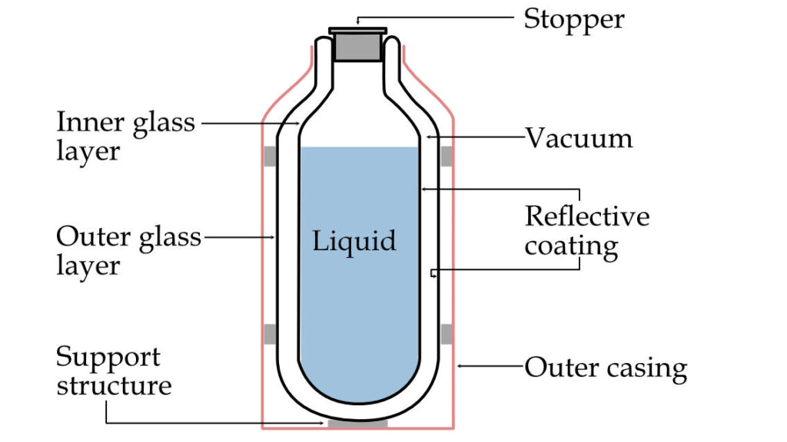
- Stopper and support -> plastic -> prevent conduction
- Silver glass wall -> prevent radiation
- Vacuum -> prevent convection and conduction

5.4 Energy sources

Fossil fuels
- Formed from dead plants and animals buried millions of years ago
- Take a very long time to replenish
- = non-renewable energy source
Coal
- Directly used as fuel
- Used in power station
Crude oil
- ❌ used as fuel
- Processed to produce petrol, LPG, diesel oil…
Natural gas
- Use directly as fuel
- For cooking and fuel in cars
- In HK: Generating electricity and produce town gas

Concerns about using fossil fuels
Limited supply
- Reserves are limited
Pollution
- Burning of fossil fuels releases many harmful substances such as nitrogen oxidizes, sulphur dioxide, lead and carbon monoxide
- Cause air pollution -> health problem (irritate eyes and throat, cause dizziness and headaches, cause respirational diseases such as bronchitis and asthma
- Global warming
- Sulphur oxide and nitrogen oxides -> acid rain -> cause harm to fish and other aquatic life

Alternative energy sources

Non-renewable
Nuclear power
- 25% of electricity came from Guangdong Daya Bay Nuclear Power Plant
- Nuclear fuels undergo reactions which releases heat
- Boil water to steam
- Drives a turbine
- Drives a generator that produces electricity

Renewable energy sources
- Can be replenished in a short period of time
- Have limitation
Solar energy
- Collected using solar collectors or solar panels
- Used to produce hot water or electricity
- Limitation
  - Affected by daylength and sunlight intensity
  - Is costly to build and install
Wind power
- Converted into electric energy using wind turbines throughout the world\
- Limitation
  - Depend on the availability and speed of the wind\
  - Create noise pollution and birds are killed
  - Make landscape look unsightly
Hydroelectric power
- Dam is built
- Energy of moving water
- Flowing water from reservoir turns the turbine and generate electricity
- Limitations
  - Destroys land and water habitats
  - People need to move away

Biomass energy
- Burn wood, crops, and animal waste
- Converted to heat and light
- -> biofuels, power vehicles, heating and cooking
- Limitation
  - Land
  - Price of crops increase
  - Attract pests such as rats and flies

Saving energy
Solve problems -> save energy
Ways
- Turn off electric appliances when not in use
- Use public transport
- Use staircase
New tech
- Double glazing windows
- Energy-saving escalator
- Light tubes
- Electric vehicles

Chapter 6 Matter as Particles

6.1 What is matter
- Matter: has mass, takes up space

5 Basic idea of particle theory
- Very small
- Take up space
- Different matter different particle
- Different particle different size and masses
- Moving all the time
- Empty spaces between them

Evidence
Smell perfume outside of balloon
- All matter ae make out of particle
- Empty spaces
- Different matter difference particle
- Difference particle difference size and masses
Mixing water and alcohol
- Volume slightly less
- Mass same
- All matter is made up of particle
- empty spaces
- Different matter different particles
- Different particles different sizes and masses

Type of particles
- Atoms are the basic type of particle making up matter
- Some substances are made up of one kind of atom
- Some substances are made up of small particle molecule
- which consists of atoms

Chemical formula of a molecule
O₂
Symbol of oxygen + Number of oxygen atoms
H₂O
Symbol of hydrogen + 2 + Symbol of oxygen (omit 1)

6.2 Particle model
Model in science
- To study and explain how things work
- Illustrates structure of objects, real systems and concepts
Particle model
- Describe arrangements and movements in solids, liquids and gases
Solid | Liquid | Gas
Close and regular  Vibrate about fixed position | Close but irregular  Move around each other | Far apart  Move freely in all direction
⮽ Fixed shape  ⮽ Compressed | ☑Compressed  ⮽Fixed shape | ☑Compressed  ☑Fixed shape

6.3 Dissolving
- Sugar: sugar particle, Water: water particle
- Sugar particles separate and mix with water particles
- Too small to be seen Disappear
- Evenly spread out
Volume?
- Water particle fit into spaces between bigger sugar particles
- Volume is slightly less
Mass?
- Remains unchanged
- Number of particles remains unchanged

6.4 Thermal expansion and contraction
Temperature is higher Particle move fasterFurther apart
substance as a whole decreases in size
Daily applications
- Thermometer: Contain liquid (e.g. coloured alcohol) which expands and contracts when the temperature changes
- Fire sprinkler: Heat cause the liquid inside the glass tube to expand which breaks the glass tube and water flows out

6.5 Gas pressure
- Gas can move freely in all directions
- Constantly hit the wall of the container push
- Total push = gas pressure
Applications
- Aerosol can
- Airbag of a car

Effects on air temperature
Temperature of a gas increases gas particle moves faster hit the container wall harder and more frequently Gas pressure increases

Volume of a gas reduced Air particles hit the wall more frequently Gas pressure increases

Atmospheric pressure
- Hit by air particles in atmosphere pressure
- Atmospheric pressure / air pressure
- Is very strong
- Pressure inside our bodies balance the air pressure
Applications
- Suction cup
- Vacuum cleaner

